**CS4001 Programming**

**Coursework: GadgetShop**

**Student ID: 22041310**

**Table of Contents:**

**Coursework: GadgetShop ………………………………………………………………………… 1**

**UML Class Diagram ………………………………………………………………………………….. 3**

**Functionality ……………………………………………………………………………………………. 4**

**Testing ……………………………………………………………………………………………………… 8**

**Reflection ………………………………………………………………………………………………. 14**

**UML Class Diagram:**

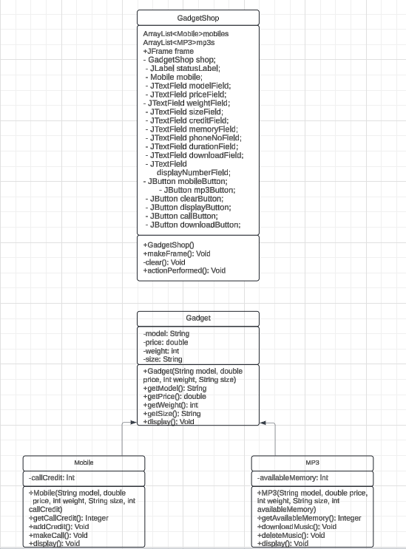

**Functionality** (a short description of each methods in Gadget.java, Mobile.java and MP3.java):

**Gadget.java**:

public String getModel() - get method to return the value for model.

public double getPrice() - get method to return the value for price.

public int getWeight() - get method to return the value for weight.

public String getSize() - get method to return the value for size.

public void display() - to print/display the gadget details (doesn’t return anything).

**Mobile.java**:

public int getCallCredit() - get method to return the value for call credit.

public void addCredit(int credits) - void method to add credits to the call credit value. Validating credit, if value is valid then add credit.

public void makeCall(String phone, int duration) - void method to make a call.

public void display() - void method of displaying Mobile details and available call credit.

**MP3:**

public int getAvailableMemory() - get method to return available memory.

public void downloadMusic(int memorySize) - void method for downloading music.

public void deleteMusic(int memorySize) - void method to delete music to free up space.

public void display() - void method to display MP3 details and available memory.

**Pseudocode for button-handling methods, textboxes, input check with try/catch, buttons and action performed methods:**

**“Add mobile” button:**

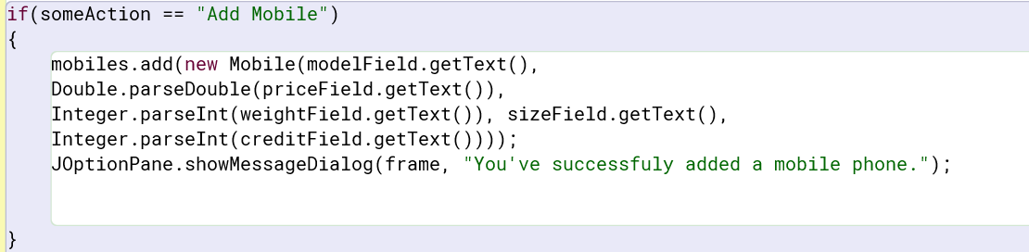

**“Add mp3” button:**

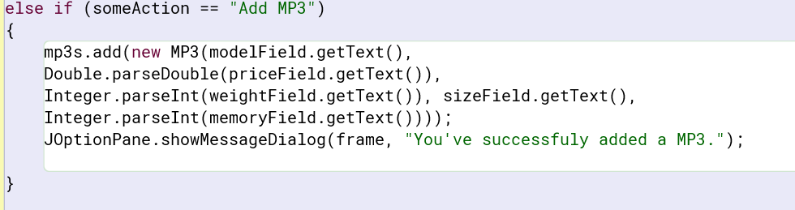

**“Make a call” button:**

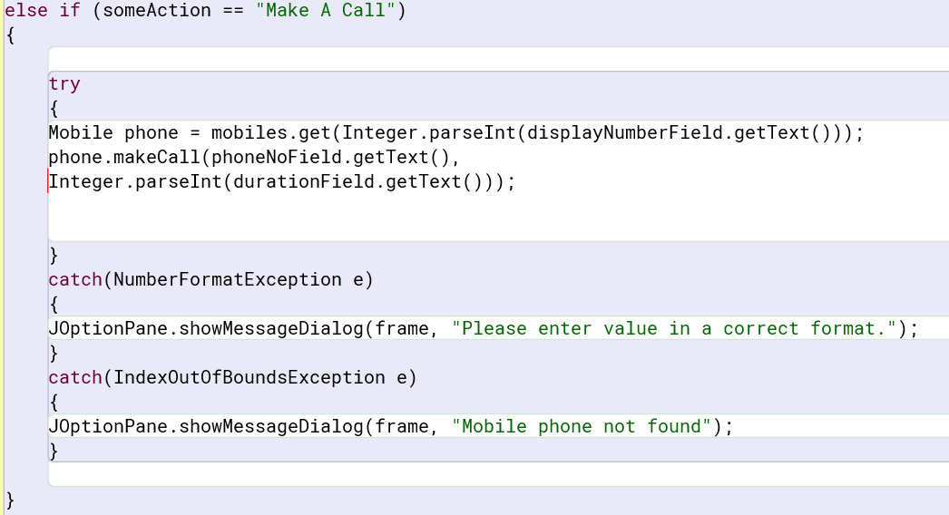

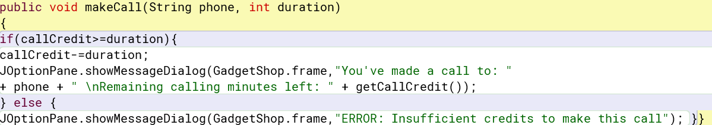

**“Download music” button:**

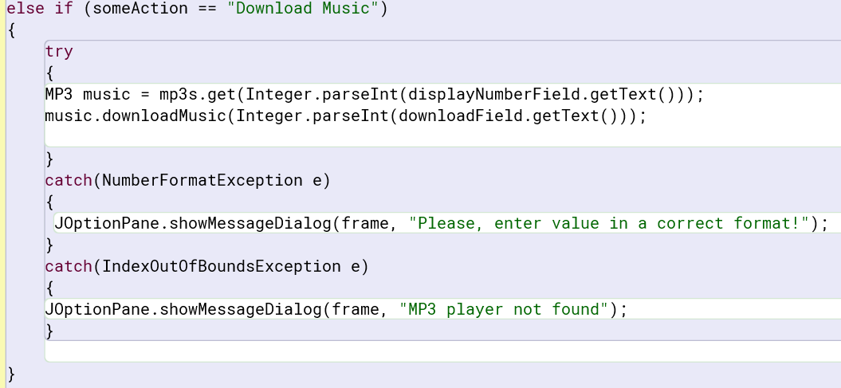

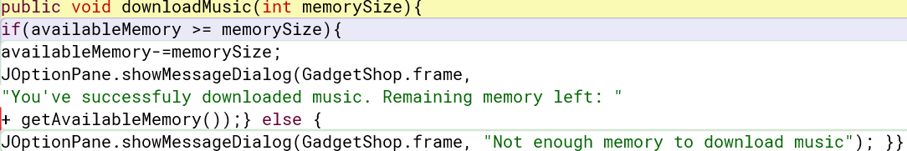

**“Display All” button:**

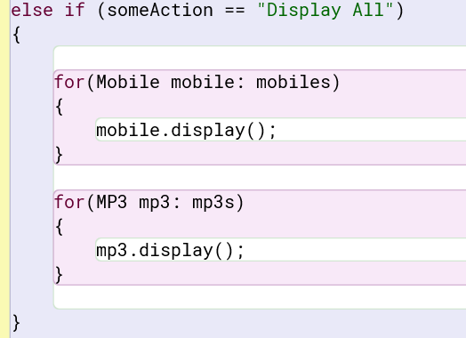

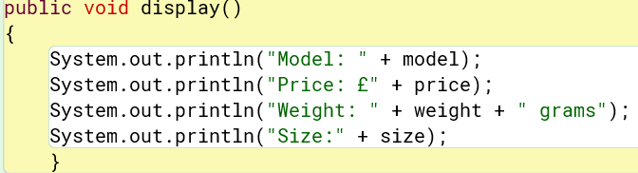

**Testing:**

**“Adding a mobile to the array list”:**

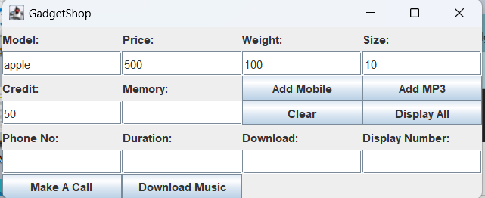

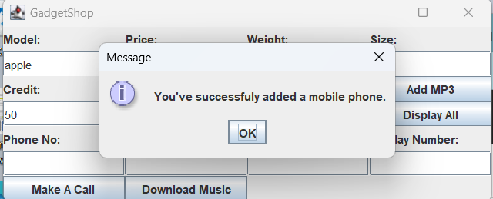

**“Adding an MP3 to the array list:”**

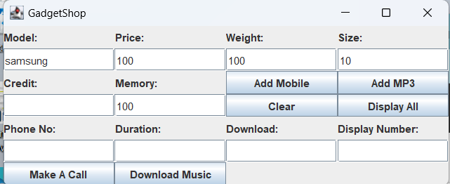

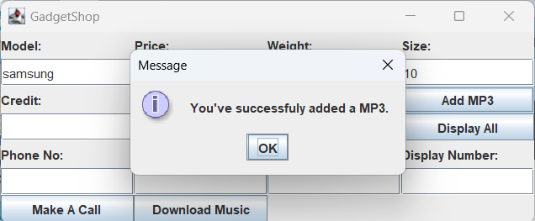

**“Displaying details of all gadgets in the array list”:**

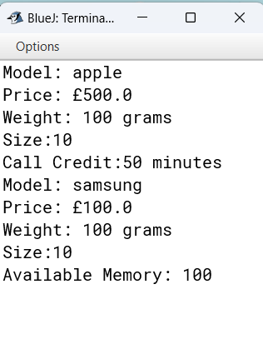

**“Making a call”:**

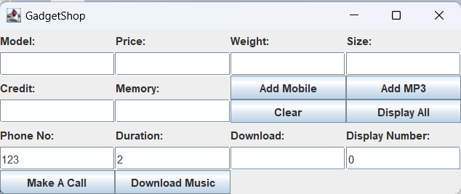

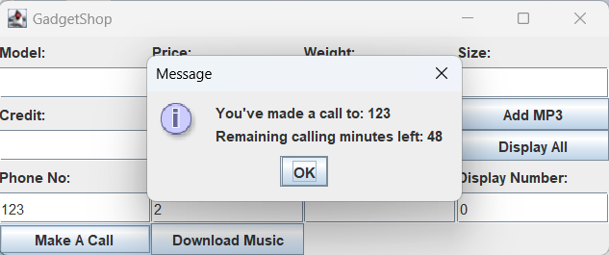

**“Download music”:**

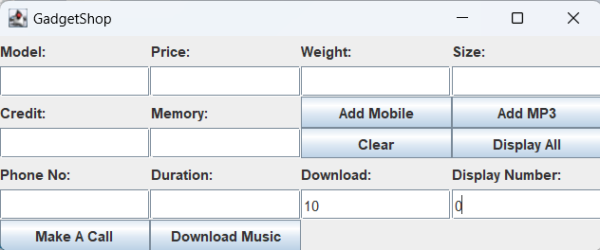

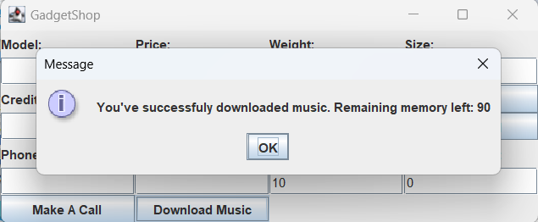

**“When you typed unsuitable values”:**

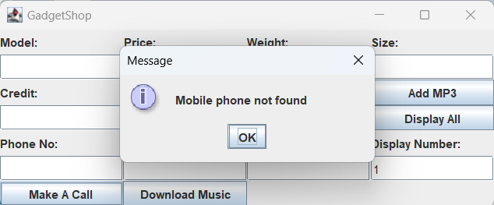

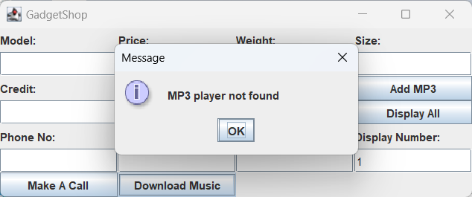

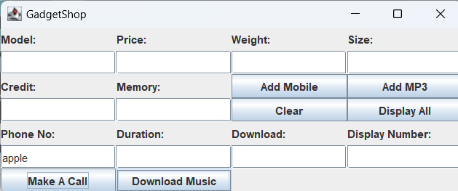

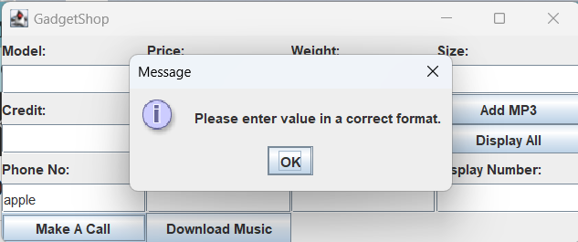

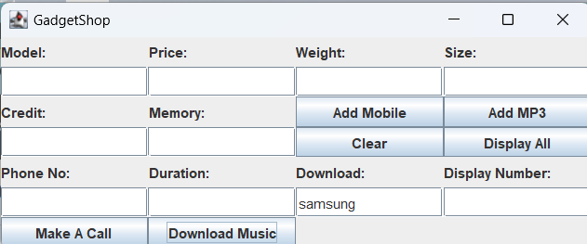

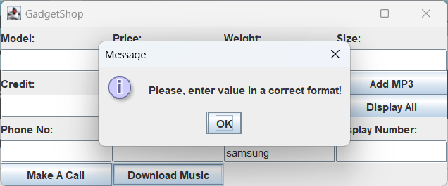

**Reflection:**

I spent a lot of time on my coursework. But I don’t regret my time spent as during this time I learned a lot about Java. It was very difficult for me from the very beginning, but after watching several videos about Java, I finally began to understand how Java works ( thanks to Intellij IDEA platform ).

The hardest thing for me was to make a program with just one array <gadget>, so instead of that I made two arrays <mobile> and <mp3> as it was easier for me to finish my program on time this way.

Below are some of my mistakes:

**I forgot to write a line with:**

**String someAction = event.getActionCommand(); this line needed to button work.**

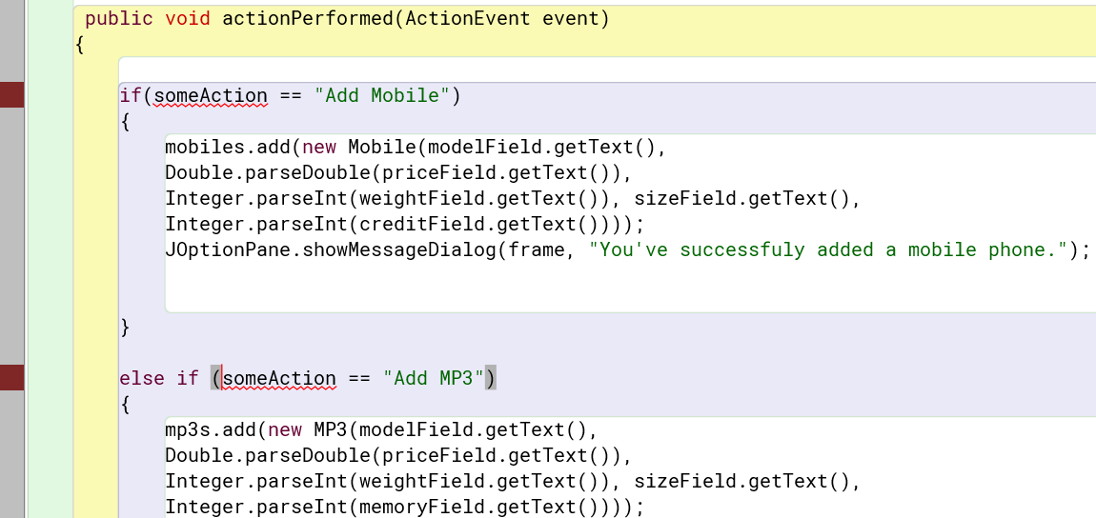

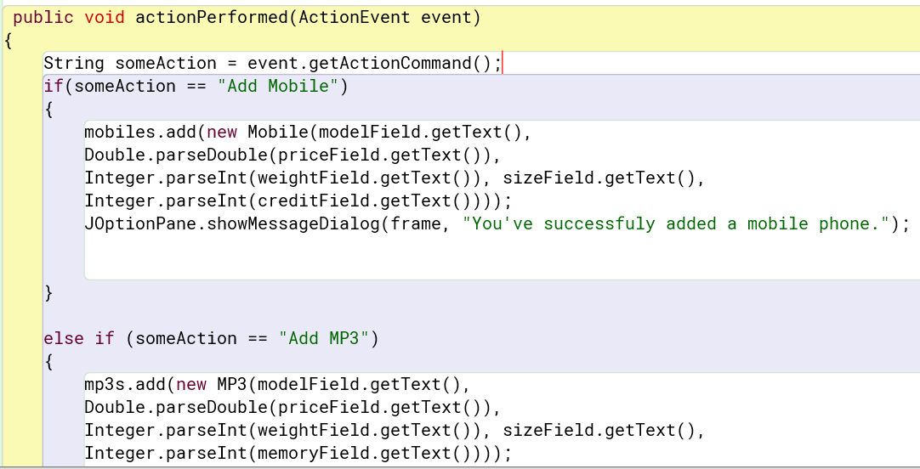

**The second mistake was – I forgot to make JFrame frame static, so I can use Gadget.frame in mobile class:**

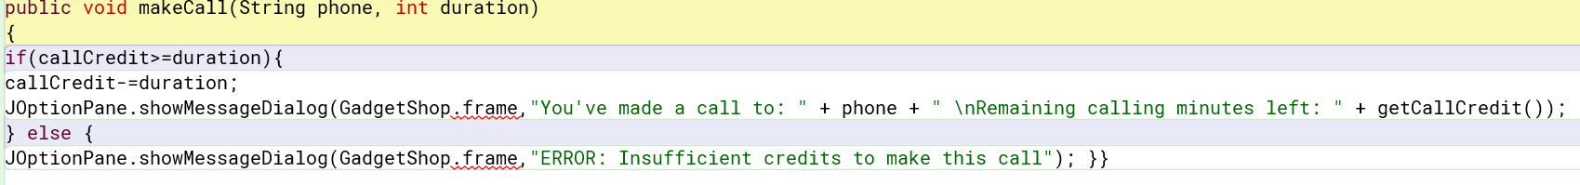



**The third mistake was I forgot to make two array lists:**

